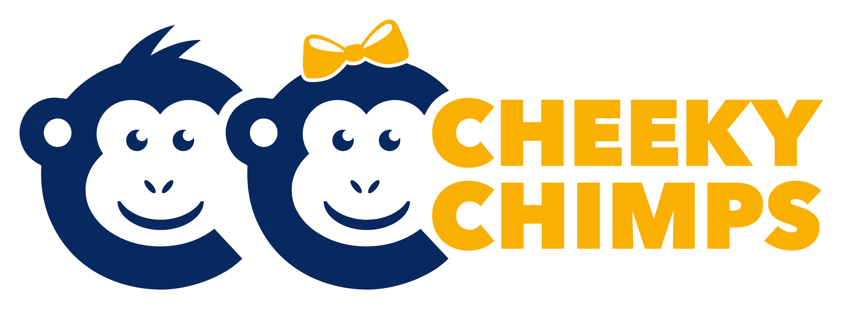

Assessment Policy
September 2019

Introduction
The purpose of this policy is to describe our assessment procedures at Cheeky Chimps. Assessment is an essential part of the learning and development of children in Early Years. Our accurate assessment depends on us getting to know our children very well and to this end we gather information from a range of sources including observations of the children engaged within child-led/independent learning as well as during adult-led activities. We also do this through discussions with parents and carers and by talking to the children. We use the following key documents to underpin our practice in the Early Years: Statutory Framework for the Early Years Foundation Stage (DfE, 2017), Early Years Foundation Stage Profile handbook (DfE, 2016), Development Matters (Early Education, 2012) and Early Years Outcomes (2013).

Process
Children will be assessed three times a year (each long term September – Dec, Jan- March and April to July.)

There will be 3-4 ‘Focus Children’ a week. During this week staff will aim to gain 5-7 observations looking at how they play and their development. These assessment will include the development matters statements from the EYFS.

Staff will also complete their mark making sheets and assess children’s speech and language using an ECAT form.

Once staff have completed their assessments they will arrange a key worker meeting where they will discuss the assessments made.

In addition to this staff will observe children’s ‘Wow’ moments the rest of the time. These observations will be short and probably only include a photo and a title.

